VES-WCCBM

SY IT SEM IV SOFTWARE ENGINEERING PRACTICAL-5

## Purpose of Interaction Diagrams

The purpose of interaction diagrams is to visualize the interactive behavior of the system. Visualizing the interaction is a difficult task. Hence, the solution is to use different types of models to capture the different aspects of the interaction.

Sequence and collaboration diagrams are used to capture the dynamic nature but from a different angle.

The purpose of interaction diagram is −

* To capture the dynamic behaviour of a system.
* To describe the message flow in the system.
* To describe the structural organization of the objects.
* To describe the interaction among objects.

## How to Draw an Interaction Diagram?

As we have already discussed, the purpose of interaction diagrams is to capture the dynamic aspect of a system. So to capture the dynamic aspect, we need to understand what a dynamic aspect is and how it is visualized. Dynamic aspect can be defined as the snapshot of the running system at a particular moment

We have two types of interaction diagrams in UML. One is the sequence diagram and the other is the collaboration diagram. The sequence diagram captures the time sequence of the message flow from one object to another and the collaboration diagram describes the organization of objects in a system taking part in the message flow.

Following things are to be identified clearly before drawing the interaction diagram

* Objects taking part in the interaction.
* Message flows among the objects.
* The sequence in which the messages are flowing.
* Object organization.

Following are two interaction diagrams modeling the order management system. The first diagram is a sequence diagram and the second is a collaboration diagram

### **The Sequence Diagram**

The sequence diagram has four objects (Customer, Order, SpecialOrder and NormalOrder).

The following diagram shows the message sequence for *SpecialOrder* object and the same can be used in case of *NormalOrder* object. It is important to understand the time sequence of message flows. The message flow is nothing but a method call of an object.

The first call is *sendOrder ()* which is a method of *Order object*. The next call is *confirm ()* which is a method of *SpecialOrder* object and the last call is *Dispatch ()* which is a method of *SpecialOrder* object. The following diagram mainly describes the method calls from one object to another, and this is also the actual scenario when the system is running.

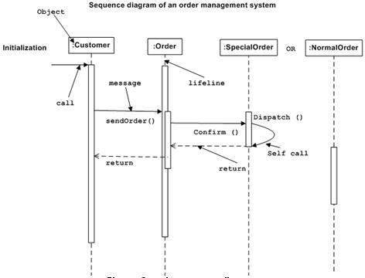

### **The Collaboration Diagram**

The second interaction diagram is the collaboration diagram. It shows the object organization as seen in the following diagram. In the collaboration diagram, the method call sequence is indicated by some numbering technique. The number indicates how the methods are called one after another. We have taken the same order management system to describe the collaboration diagram.

Method calls are similar to that of a sequence diagram. However, difference being the sequence diagram does not describe the object organization, whereas the collaboration diagram shows the object organization.

To choose between these two diagrams, emphasis is placed on the type of requirement. If the time sequence is important, then the sequence diagram is used. If organization is required, then collaboration diagram is used.

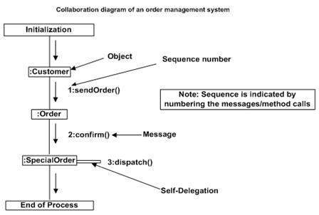

## Where to Use Interaction Diagrams?

We have already discussed that interaction diagrams are used to describe the dynamic nature of a system. Now, we will look into the practical scenarios where these diagrams are used. To understand the practical application, we need to understand the basic nature of sequence and collaboration diagram.

The main purpose of both the diagrams are similar as they are used to capture the dynamic behavior of a system. However, the specific purpose is more important to clarify and understand.